**MBF Closed loop setup**

**Code location**

Git clone <https://github.com/alunmorgan/Multi-bunch-feedback-applications.git>

Add the resulting folder to your Matlab path.

**Machine setup**

Inject to 30mA 900 bunches (below the instability threshold)

The following Matlab code will run a system phase scan on each axis sequentially. The graphs will be displayed, and the data is automatically stored.

**>> modscan_all('x')**

**>> modscan_all('y')**

**>> modscan_all('s')**

**Assessment**

Use the modescan results to assess whether the closed loop delay is good enough.

This is an example of the output.

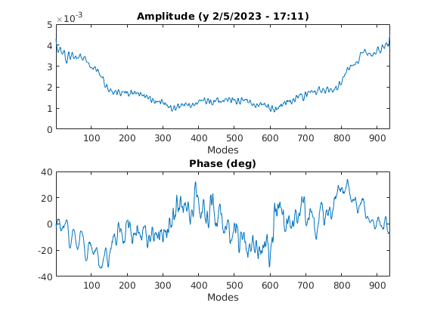  
The amplitude should be fairly symmetric in the modes axis

The phase variation should be much less that ±90o and the extents should be balanced between going above and below zero

A large phase variation indicates that a component is failing – probably the output amplifier. So, a hardware change and a retuning of the frontend is required.

A significant asymmetry in the distribution of the extents of the phase trace indicates that the overall loop delay is not correct. This can be fixed in the following ways.

* First see if the 2ns DAC delay can fix it
* Otherwise, we must change cable lengths in the CIA

**Tuning the loop delay**

Use the mbf_modescan_setup Matlab code to setup the measurement and look at the ‘tune’ screen.  This gives a live modescan you can use for monitoring the impact of your changes.

The following Matlab code will set up this visualisation for each axis

Note: You generally work on a single axis at a time

**>> mbf_modescan_setup('x')**

**>> mbf_modescan_setup('y')**

**>> mbf_modescan_setup('s')**

The aim of this exercise is to get the extents of the phase trace comfortably fit within the ±90o limits.

**Tuning the DAC delay**

This allows additional phase (delay) to be added to the closed loop. However, it can only add in steps of 2ns. Use this setting first to get as close as possible to the target performance. Any remaining adjustment will have to be done with physical cable length changes.

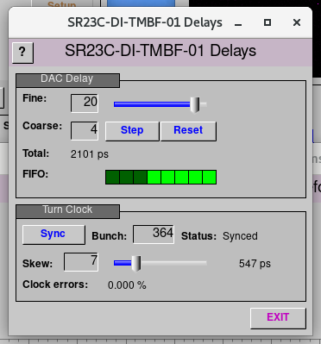

**Tuning the cable length**

Modify the cable length until the extents of the phase trace comfortably fit within the limits.

The cable is in CIA23 Diagnostics rack 02 and is the output of the output amplifier (labelled RF Out).

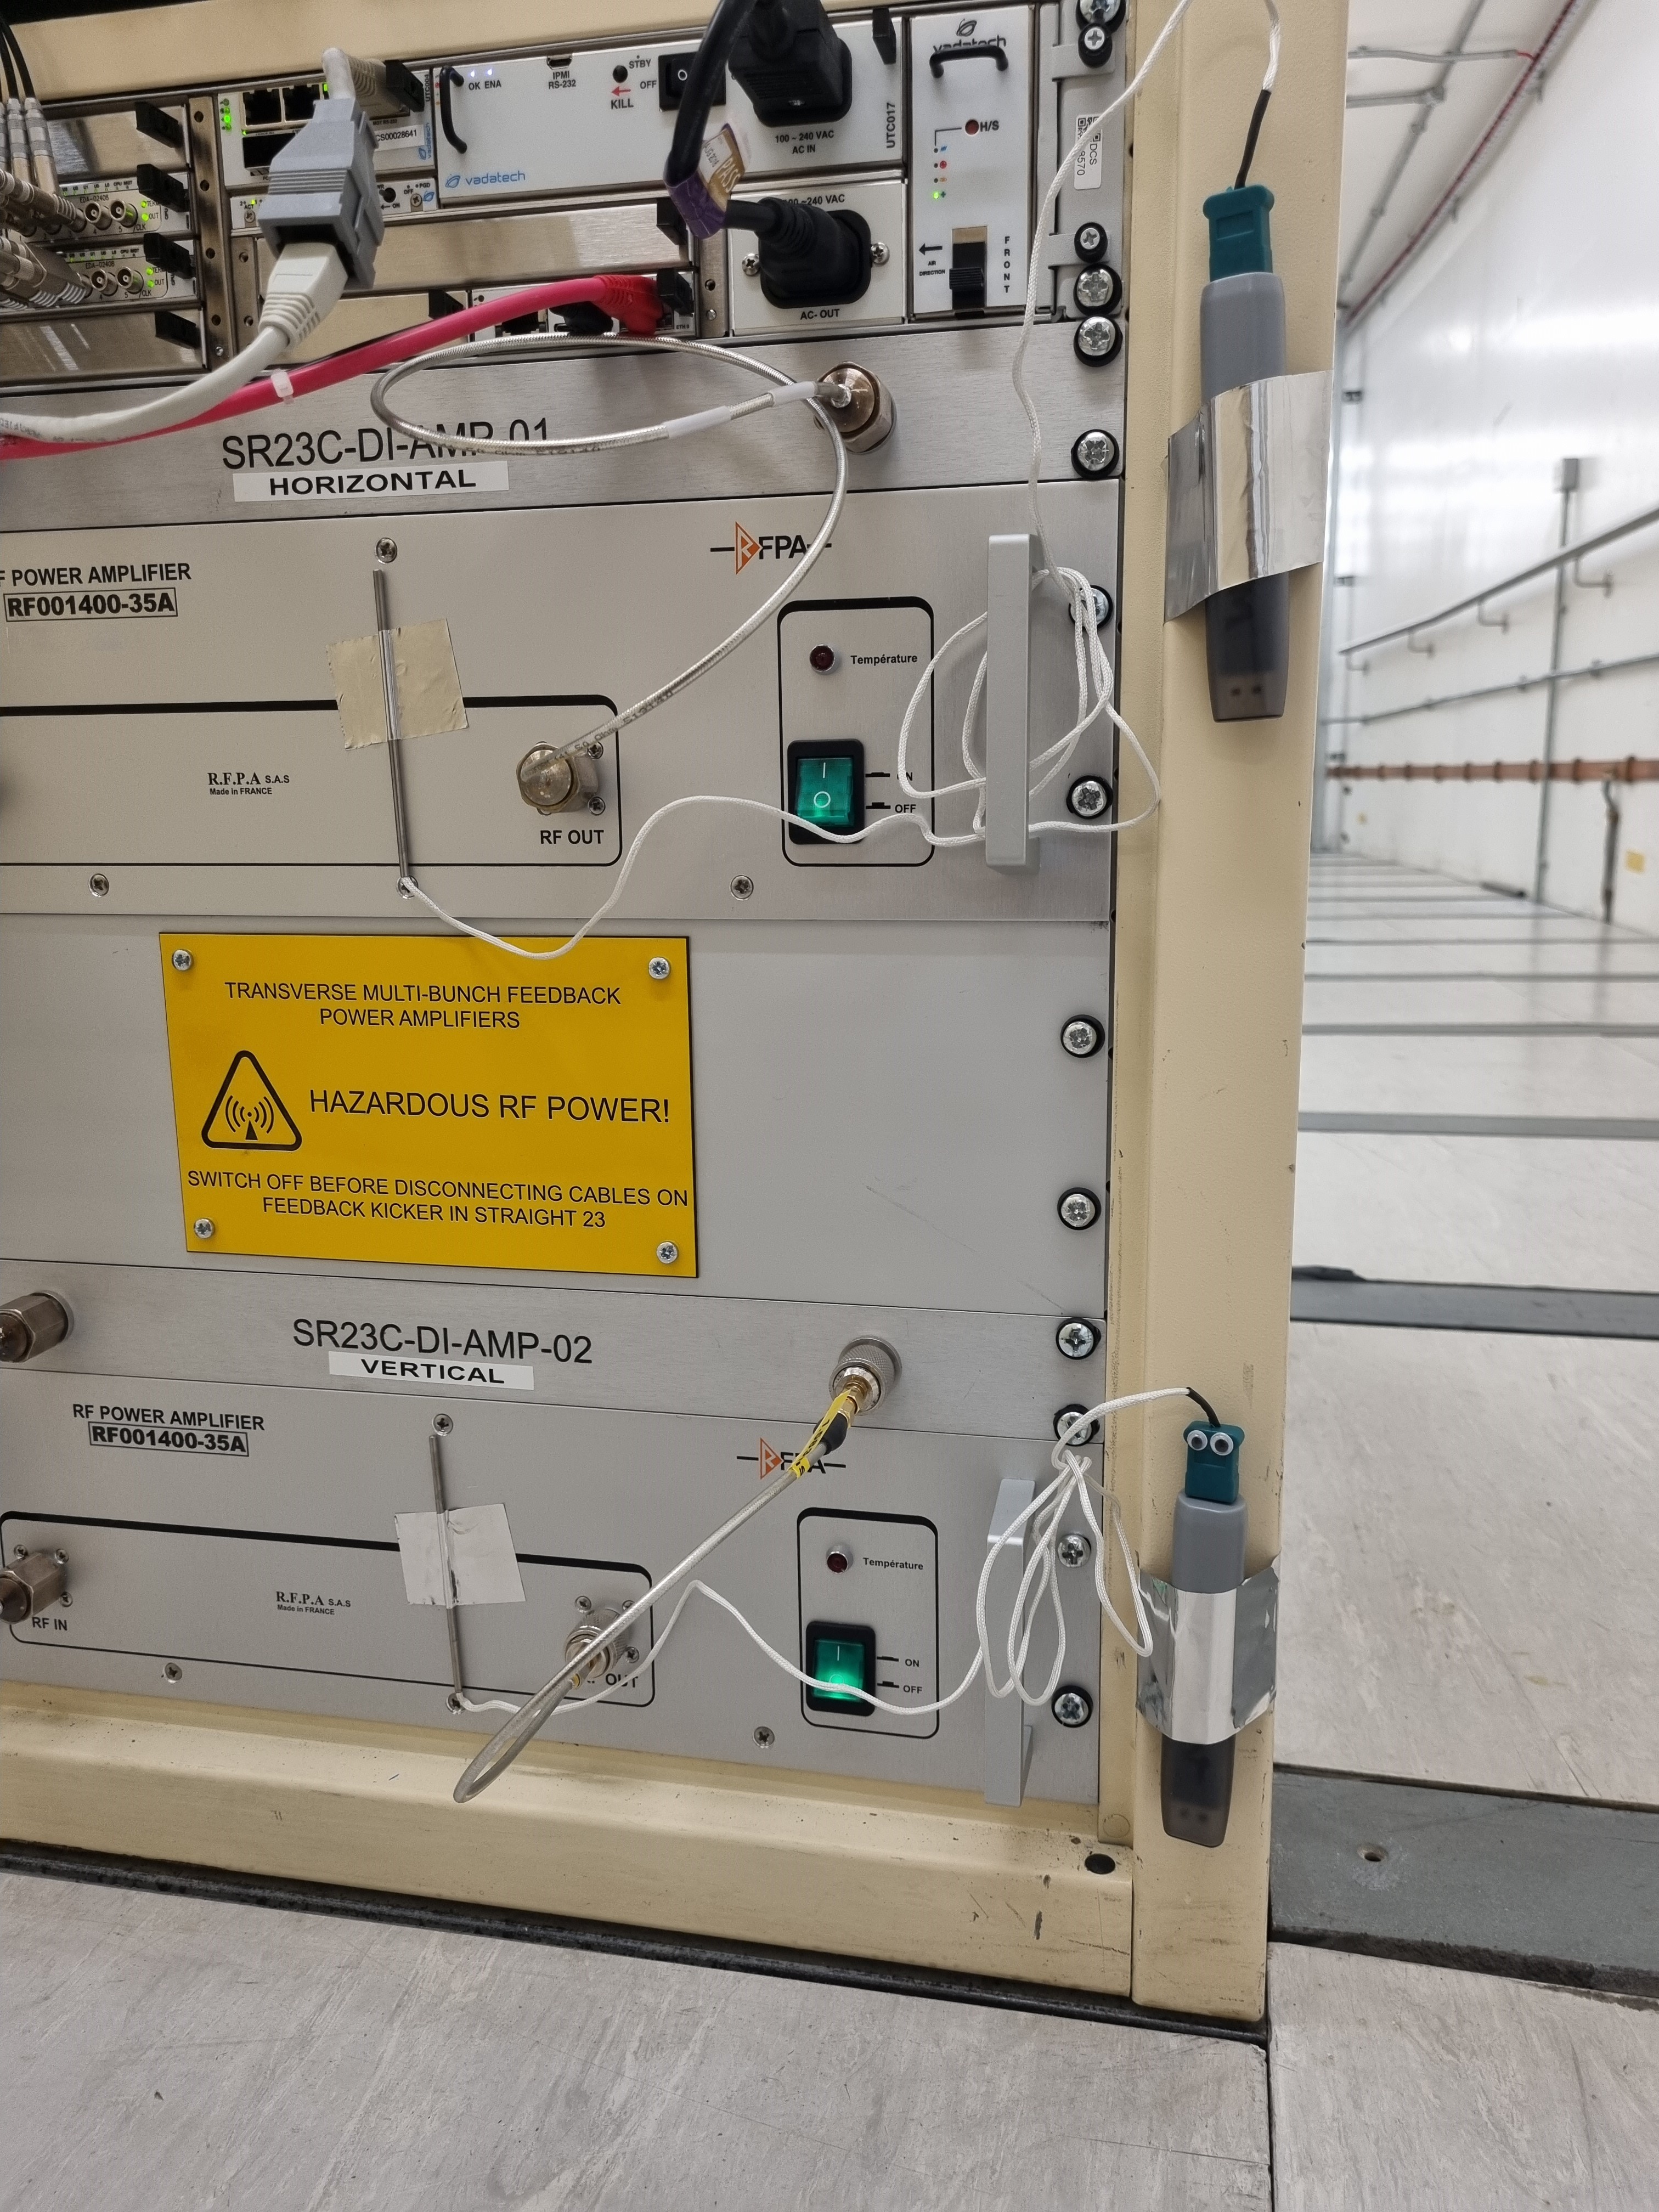

**At this point the full loop delay should be optimised**